CS 3021: Computer Architecture 2
Tutorial 4

Ryan Barron
Student n° 16329561

Question 1:

1) O1 to Mux6 and 2) O1 to Mux6 and O0 to Mux 7 (simultaneously)

The following instruction will lead to those datapath:
ADD R1 R1 R2
ADD R2 R1 R2
ADD R1 R1 R2

Screenshot:
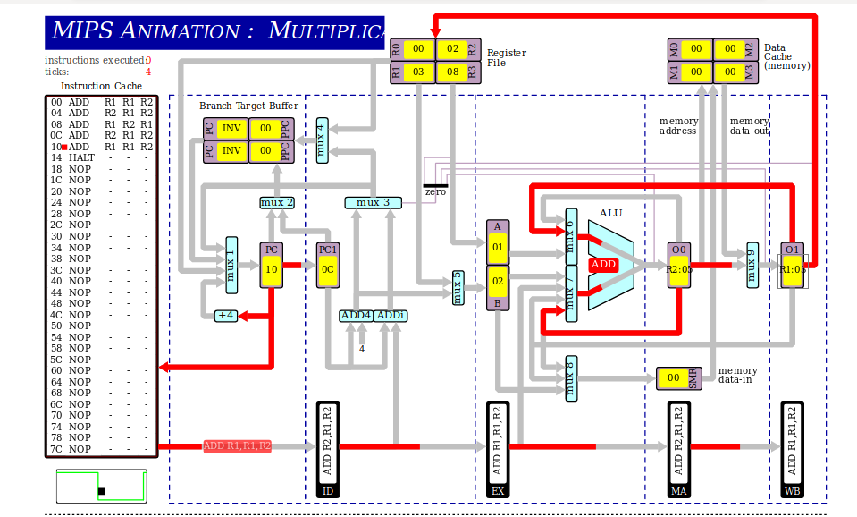

3) O0 to Mux8

ADD R1 R2 R1
ST R1 R0 R3

Screenshot:
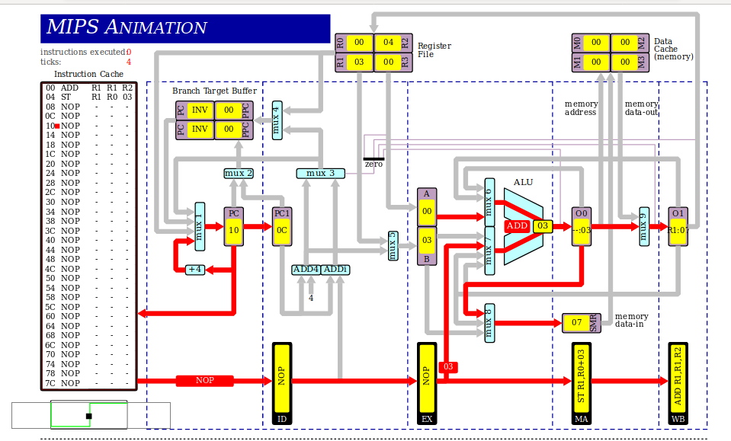

4)EX to Mux7
An add constant instruction will cause that datapath
ADDi R1 R1 07

Screenshot :
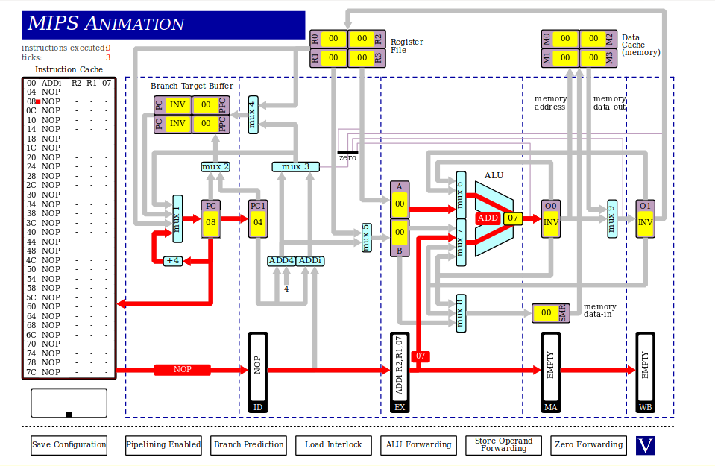
5)Data cache to Mux9
A load instruction
LD R1 R1 02

Screenshot:
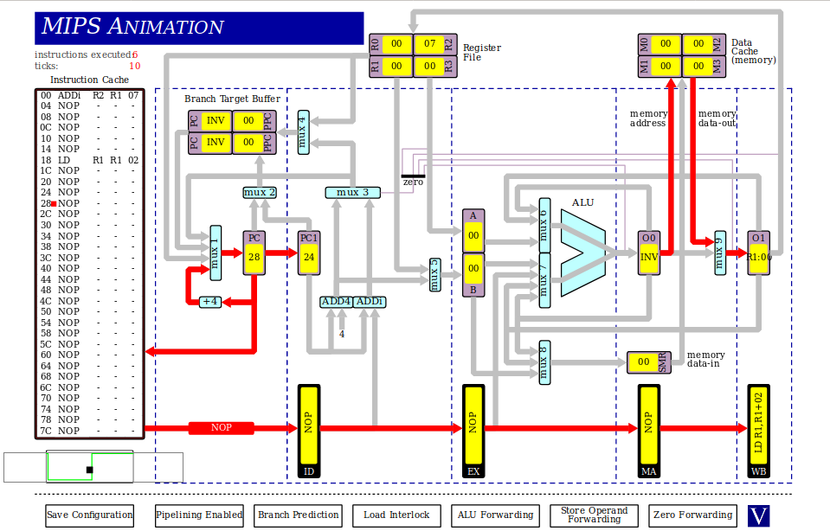
6)O0 to zero detector
An ALU instruction followed by BEQZ or BNEZ

ADD R0 R0 R0
BEQZ R0 38

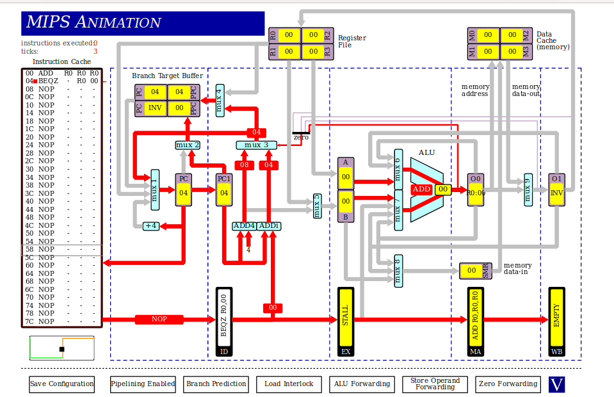
Screenshot:
7) Register file to Mux1

JR R1

Screenshot:
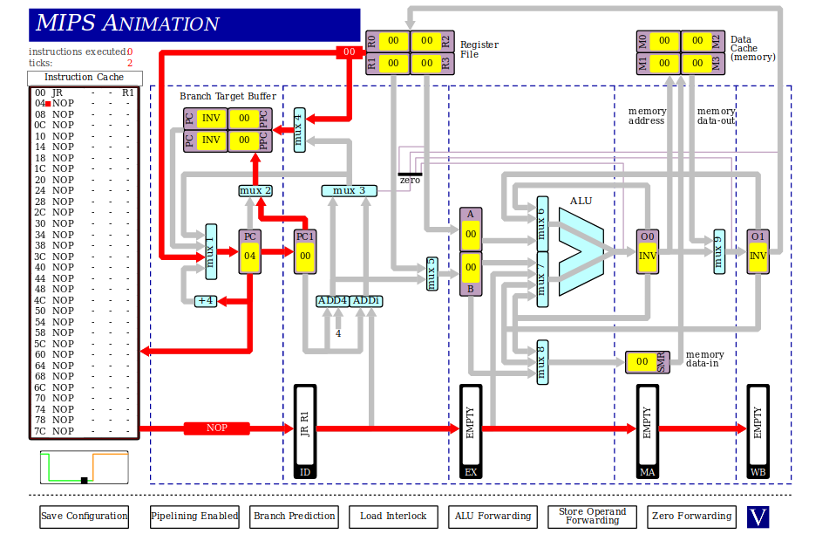
8)Branch target buffer to mux1

ADD R1 R1 R1
J FC

Screenshot:
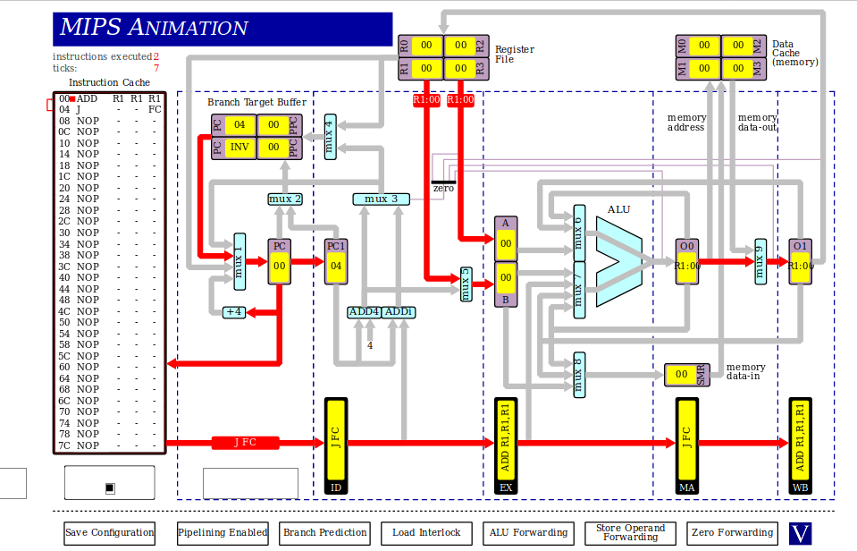

Question 2:

With ALU forwarding, it takes 10 clock cycles to execute the program and the resulting value in r1 is 0x15 or 21.
Without ALU forwarding, it takes 18 clock cycles to execute the program and the resulting value in r1 is 0x15 or 21.
Without CPU interlocking, it takes 10 clock cycles to execute the program and the resulting value in r1 is 0x6 or 6.

Without CPU interlocking, the pipeline run normally. It takes 10 clock cycles because it need to first fill up the pipeline at the beginning so it spends 4 clock cycles without having any instruction finish. After that, on every clock cycles, one instruction finish executing and the program is 6 instruction so it takes 6 clock cycles to finish executing and execute all the instructions. For the result, without any interlocking mechanism, there is nothing to care of data hazards so nothing is done. So all the instruction after the first ADD are done with different values than that of the resulting previous instruction. It is as if the two previous instruction didn’t happen.
It uses the previous values for its instruction, so the semantic of the sequence of instruction is lost. The program is executed in a different way than expected. The last two instruction before the last one are completely useless.
With CPU interlocking, the pipeline will stall out when data hazard are detected and so for each data hazard, 2 clock cycles are added, the IF and ID phase get re-executed, waiting for the previous instruction to reach the WB phase. In our program there are 4 data hazard, so it adds 8 clock cycles. On the other hand, the semantic of the program is preserved and so the result in R1 is the expected result of the sequences of instruction.
With ALU forwarding, the are two added register in the MA and WB phase. The goal is to remove any stall due to data hazards. The result is the same as in the last case, interlocking is present so the semantic is preserved. But the execution time is faster because no instruction need to wait for the WB phase of any previous instruction. During the ID phase, the instruction will fetch the value of the operands in the register file. But in the EX phase it will check the OUT register in the next two stages to see if one of the two previous instruction computed a new value for its operands. That way, we are certain we have the up-to-date values in the EX stage. The other values can either be in the register file, if a previous instruction got completed, or they can be in one of the OUT register, if the instruction are ahead in the pipeline but have not writing back in the register file before the EX stage.

Question 3:

i) 39 instructions are executed in 51 clock cycles. The are two reason for these numbers to be different. The first one, I already explained it in the previous question, but the pipeline needs to fill up at the beginning, so the first four clock cycles do not complete any instruction, the first instruction is completed on clock cycles 5. The second are stall due to load and branch hazard. Every we load a value in R2 from main memory, the next instruction uses R2 and has to stall for a cycle for the correct value. The other stalls come from the branch target buffer due to compulsory miss or the prediction was wrong.
In the end there are 8 stalls through the execution of the program. So that’s 4+8=12 cycles that do not complete an instruction, all the rest does. That is why the two number are different 51 – 12 = 39

ii)Without any branch prediction, it takes 53 clock cycles to execute the program. The difference here is that every time a jump / branch is taken, there is a stall. For example everytime that “J E0” there is a stall which is different from the last case. With branch prediction unconditional jumps / branch will only stall the first time, or if there is an overflow in the buffer which leads to a capacity miss. So, with the branch prediction is only happened once that the J E0 cause a stall. For the other two branches it is a bit different. Without any prediction, they will only stall when the branch is taken because the CPU systematically fetches the PC+4 instruction and needs to fetch the correct one. With branch prediction, it works the same at first, when the branch was never encountered.
But once it is, the result is stored in the buffer and so next time, the PC will immediatly be updated to the value stored in the buffer. Now whether the CPU takes the branch or not, a stall can happen if it turns out that the behaviour changed, the next time that branch is encountered. If last time the branch was not taken but is taken the next time, a stall with occur. That’s the same as with no prediction, but the reverse can happen as well. If the branch was taken, the next time, the branch will be taken again. It will create a stall if the branch should not have been taken. That’s a new type of error that does not occur without any form of branch prediction.
So in the end, more stall occur without the branch prediction than with it.

iii) When the two shift instruction are swapped, it only takes 47 clock cycles to execute the program and that is because it removes all the load hazard. Before the swap, the instruction right after the load, used the target of the load as an operand. That is why we had a stall in the first place. By swapping the instruction, the instruction right after the load doesn’t use R2, so no stall. In essence we have replaced the stall by the other shift instruction, hence the speed up in execution time.

